**AI ASSISTED CODING**

NAME: SHARIKHA IMTIAZ KHAN

ROLLNO: 2403A52368

TASK 1: identify and write the correct code for this

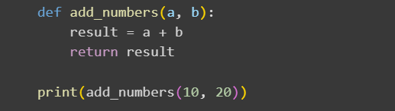

EXPLANATION:

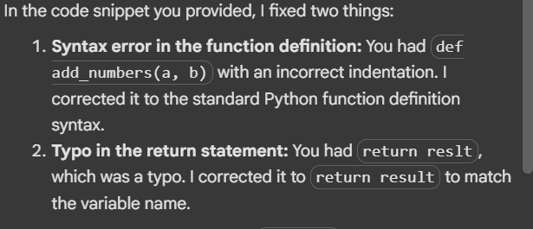

OUTPUT:



TASK 2: write the correct code for this

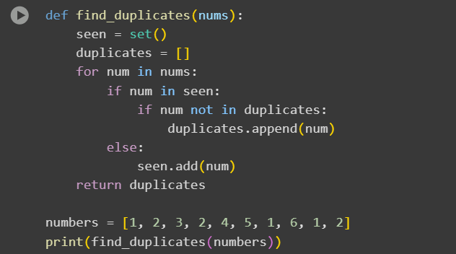

EXPLANATION:

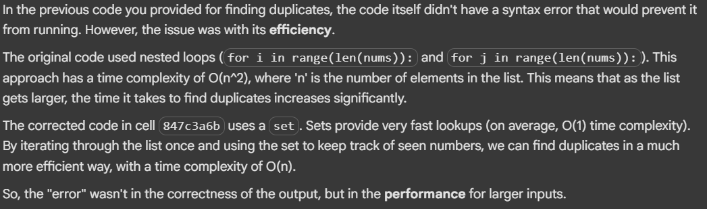

OUTPUT:



TASK 3: write the correct code for this

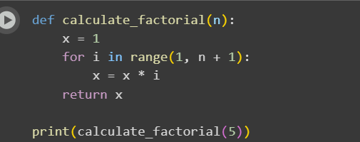

EXPLANATION:

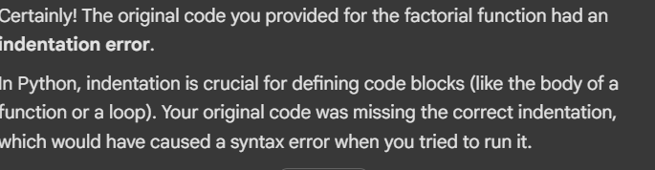

OUTPUT:



TASK4: correct this code and use try-except block

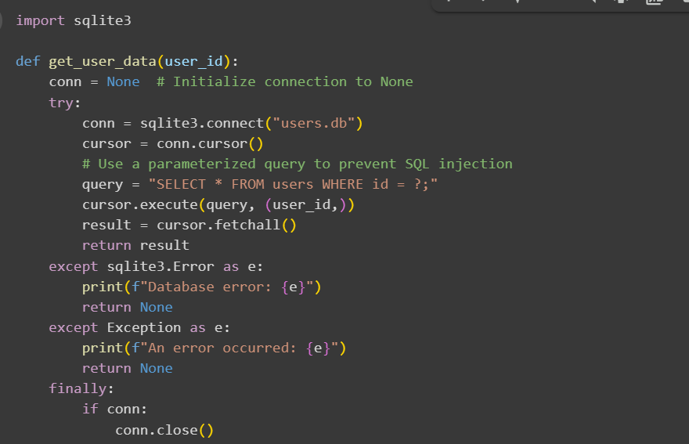

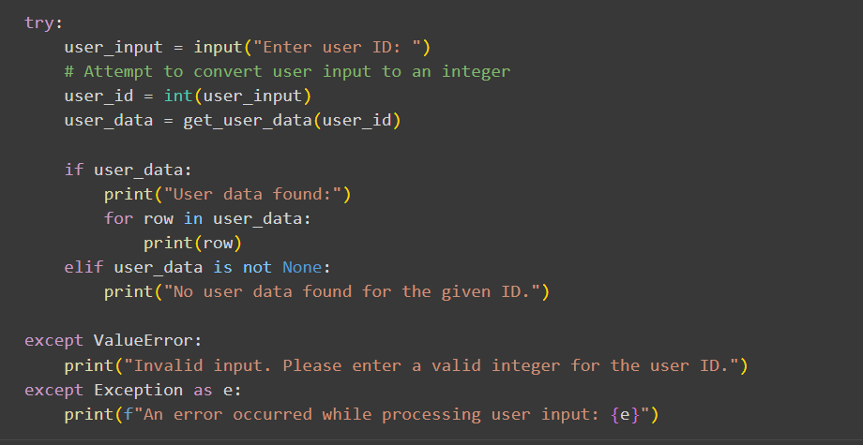

EXPLANATION:

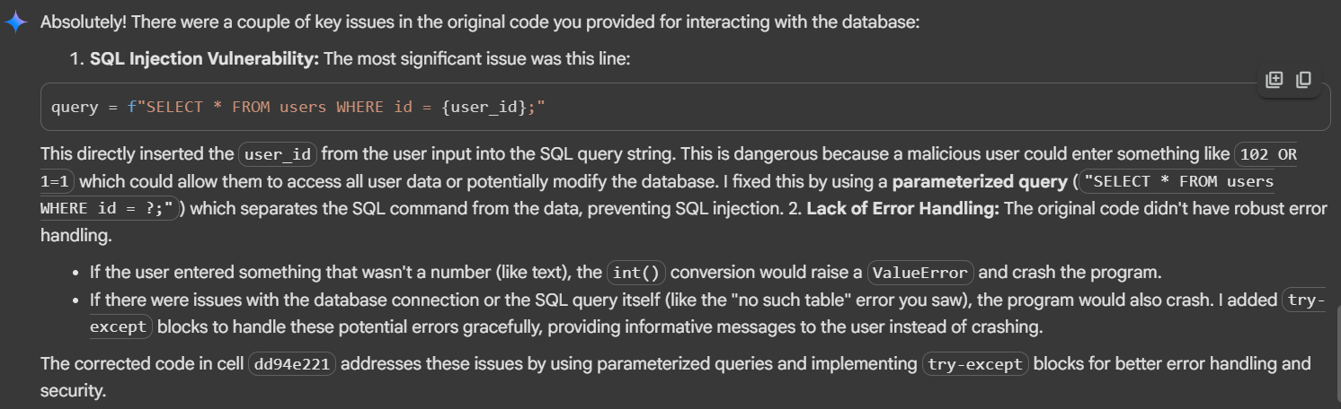

OUTPUT:

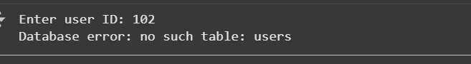

TASK 5: generate the correct code for this

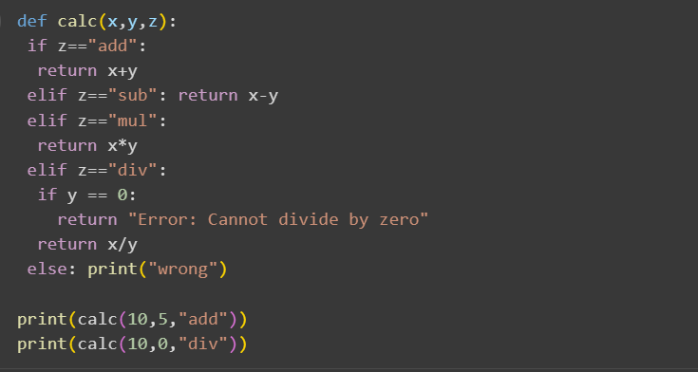

EXPLANATION:

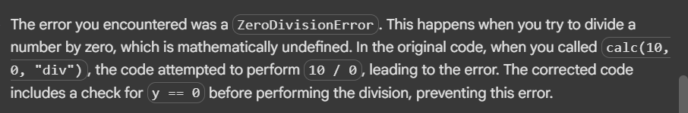

OUTPUT:

